B.tech Project Report

on

**Application of Nano-Particles in Cementing Operations**

##### Submitted by:

Utkarsh Shukla (20PE3047) & Ritam Bishnoi (20PE3034)

B-tech, 7th Semester



**Rajiv Gandhi Institute of Petroleum Technology**

##### Supervised by:

Dr. Shivanjali Sharma

Associate Professor

Department of Petroleum Engineering and Geo-Engineering

# ACKNOWLEDGEMENT

We would like to extend our heartfelt gratitude to the Rajiv Gandhi Institute of Petroleum Technology for their unwavering support in facilitating our research endeavours. The institute's provision of essential resources and state-of-the-art laboratory equipment has been indispensable in the successful execution of our project.

We would also like to express our sincere appreciation to the Department of Petroleum Engineering and Geo-Engineering for their continuous guidance and encouragement. Their support has been instrumental in navigating the challenges encountered during the course of our research.

A special note of thanks goes to Dr. Shivanjali Sharma, whose expertise in the field of nano-particles and cementing operations has been invaluable. Her mentorship has not only shaped our research ideas but has also provided solutions to the hurdles we faced.

Last but not least, we are profoundly grateful to our parents, whose unwavering support and love have been our foundation throughout our academic journey.

This project has enriched our knowledge and provided us with invaluable exposure to the intricacies of cementing operations and their applications in the oil and gas industry.

With sincere appreciation,

Utkarsh Shukla (B.Tech 4th Year Student, PEGE Department)

Email: [20pe3047@rgipt.ac.in](mailto:20pe3047@rgipt.ac.in)

Ritam Bishnoi (B.Tech 4th Year Student, PEGE Department)

Email: [20pe3034@rgipt.ac.in](mailto:20pe3034@rgipt.ac.in)

**CONTENTS**

|  |  |  |
| --- | --- | --- |
| **S. No.** | **Title** | **Page No.** |
| 1 | About the Project | 04-05 |
| 2 | Timeline | 06 |
| 3 | About Previous Work | 07 |
| 4 | About Research Facilities | 08-13 |
| 5 | About the Results | 14 |
| 6 | What we Learn | 15 |
| 7 | Future Scope | 16 |
| 8 | Conclusion | 16 |
| 9 | References | 17 |

# About The Project

Cementing is a critical process in the drilling and completion of oil wells, and it serves several important purposes in ensuring the integrity and safety of the wellbore. Cementing supports the well casing and prevents it from collapsing due to formation pressure or other downhole forces. This stability ensures the structural integrity of the wellbore, preventing damage to the casing and maintaining the well's functionality. Proper cementing practices can lead to cost savings by reducing the need for remedial work and ensuring that the well operates efficiently throughout its life cycle.

The primary goal of cementation in hydrocarbon wells is to have isolation of various zones, providing mechanical integrity and support to the wellbore casing and protecting the casing from corrosive fluid attacks. The inclusion of nano-particles in the cement enhances fresh and hardened cement’s properties and characteristics, such as strength, promotes hydration reaction, reduces leaching of calcium, resistance to water penetration, induces self-cleaning properties etc.

**Nano-Particle:**

A nanoparticle is a tiny particle or structure that has at least one dimension (length, width, or height) that is on the nanometer scale, typically ranging from 1 to 100 nanometers (nm). To put this in perspective, one nanometer is equal to one billionth of a meter (1 nm = 10^-9 meters). Nanoparticles can be composed of various materials, including metals, ceramics, polymers, and organic compounds, and they exhibit unique properties and behaviours due to their small size and high surface area-to-volume ratio. Nanoparticles have revolutionized many industries and scientific fields by enabling the development of novel materials and technologies with improved performance and capabilities. Their unique properties and versatility make them a subject of extensive research and innovation.

Nanoparticles can improve the rheological properties of cement slurries, making them easier to pump and place in the wellbore. This can be particularly beneficial in challenging wellbore conditions. Nanoparticles can also influence the setting time of the cement. By adjusting the type and concentration of nanoparticles, engineers can tailor the setting time to suit the specific well conditions and operational requirements. The use of nanoparticles in cementing should consider potential environmental and health implications. Safety protocols and disposal methods for nanoparticles should be addressed to ensure responsible use.

**Cement Composition:**

**Our Main Aim:**

The main objective of your study and experimentation, which is to increase the compressive strength of oil well cement and reduce fluid loss by applying different nanoparticles (mainly oxide) and comparing their effects, is highly relevant and has several important implications for the oil and gas industry.

**The objective of B.tech Project-3:**

The primary goal of this B.tech Project-3 is to gain a deep understanding of the principles, operation, and applications of the Ultrasonic Cement Analyzer (UCA) in the context of evaluating cement quality and integrity in oil and gas well construction. Furthermore, this project aims to contribute to the advancement of UCA technology by exploring potential enhancements, such as optimizing measurement techniques, data analysis algorithms, or hardware components, to improve the accuracy, efficiency, and versatility of UCA as a tool for assessing cement quality and integrity in wellbore applications.

In our study, we explored alternative methods for preparing slurry formulations, distinct from the conventional use of a Waring blender. Specifically, we employed a Hamilton Beach mixer as an innovative approach to achieve our research objectives.

# Timeline

This timeline outlines our project's progression, including the research phases, experimentation with different materials, and the exploration of alternative slurry preparation methods. The presentations served as important milestones for sharing our findings and receiving feedback throughout the project's duration.

* **Aug 2022**: BTP-1 project was allotted for cementing.
* **Aug 2022 - Oct 2022**: We dedicated this initial period to studying the cementing process and understanding its importance within the context of oil well construction.
* **Oct 2022**: We commenced the project, initiating the implementation of Cuttlefish bone as a part of our research.
* **Nov 2022**: Our first project presentation took place, during which we shared our initial findings and progress.
* **Jan 2023 - March 2023**: During this phase, we conducted experiments involving Zinc Oxide (ZnO) to further our research objectives.
* **March 2023 - May 2023**: We transitioned to working with Silicon Dioxide (SiO2) to explore its potential contributions to our project.
* **June 2023**: Our second presentation occurred, during which we presented our findings and developments up to that point.
* **August 2023**: We initiated the study of cement slurry preparation using the Hamilton Beach Mixer, seeking alternative methods for slurry preparation.
* **Sept 2023**: We dedicated time to studying and gaining practical experience with the Ultrasonic Cement Analyzer (UCA) to enhance our understanding of its functionality and applications.
* **Sept 2023**: Our third presentation provided an overview of our progress and insights gained from the UCA study.

Top of Form

# About Previous Work

**In BTP-1:**

In August 2022, we initiated our research and study, initially experimenting with the cement available in our lab and various cement additives. However, the results yielded a significantly high spurt loss of 47 mL, which was clearly not acceptable for our intended application in oil well cementing.

In response to this challenge, we decided to shift our focus to an alternative material: cuttlefish bone. Cuttlefish bone, known for its high calcium content and referred to as bi-calcium due to its elevated calcium carbonate levels, was chosen as a potential solution. It is recognized for its ability to contribute to the early strength development of oil well cement.

Nevertheless, our experimentation with cuttlefish bone still presented challenges. The spurt loss remained high at 45 mL, which did not meet our desired performance criteria. Furthermore, we encountered issues related to the economic feasibility and availability of cuttlefish bone as a viable additive.

This initial phase of our research highlighted the importance of addressing spurt loss and the need for a more economically viable solution. Our journey in seeking optimal additives and solutions for oil well cementing continued as we explored additional materials and methodologies to improve our outcomes.

**In BTP-2:**

In BTP-2, we made a strategic decision to incorporate Poly anionic cellulose (PAC-R) as a cement additive with the primary objective of mitigating fluid loss during cementing operations. In addition to PAC-R, we explored the use of Zinc Oxide (ZnO) and Silicon Dioxide (SiO2) as additives aimed at strengthening the cement matrix while concurrently reducing fluid loss.

To evaluate the effectiveness of these additives, we conducted a series of tests, including compressive strength tests and High-Pressure, High-Temperature (HPHT) tests. These tests were instrumental in assessing the performance and durability of the cement formulations under simulated downhole conditions.

Our approach in BTP-2 was focused on achieving a dual benefit: enhancing the cement's mechanical properties for improved wellbore integrity and concurrently minimizing fluid loss, a critical factor in ensuring effective cement placement and zonal isolation. The combination of these additives and the thorough testing regime represented a comprehensive strategy to optimize cement formulations for the demands of oil well cementing operations.

# About Research Facilities

In our research for cementing applications, we utilized various research facilities and equipment to conduct experiments, analyze data, and evaluate the performance of different cement formulations.

We’ve done our work in Drilling, EOR and Reservoir Engineering Laboratory.

1. **Waring Blender:**

A Waring blender is used to prepare cement slurries by thoroughly mixing cement powder with water and any desired additives. Proper slurry preparation is essential to achieve a uniform and consistent mixture, ensuring that the cement properties meet the required specifications.

Transformer Blender

1. **Hamilton Beach Mixer:**

While Hamilton Beach Mixers are typically associated with kitchen and culinary applications, they can be adapted for laboratory use. In cementing research, a Hamilton Beach Mixer can serve as an alternative to conventional laboratory equipment like high-shear mixers or Waring blenders for preparing cement slurries.

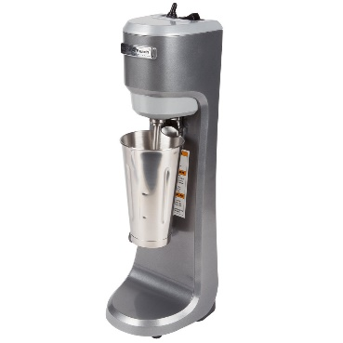

Hamilton Beach Mixer

1. **Autoclave:**

Autoclaves are designed to replicate the extreme conditions encountered in oil wells, such as high pressure and high temperature. This simulation is critical because downhole environments can subject cement to pressures and temperatures that far exceed normal atmospheric conditions. Autoclaves allow us to test cement formulations under realistic conditions, ensuring that they will perform as intended in actual wells.

Autoclave

1. **HPHT Filter Press:**

HPHT Filter Presses are designed to measure the fluid loss properties of cement slurries under conditions that closely mimic those encountered in high-pressure and high-temperature downhole environments. This accuracy in fluid loss measurement is crucial because excessive fluid loss can lead to cement placement issues, compromised zonal isolation, and casing damage.

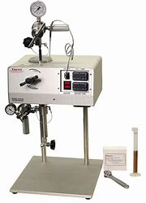

HPHT Filter Press

1. **UCS (Unconfined Compressive Strength):**

We use UCS machines to optimize cement formulations. Through controlled testing, we can evaluate the impact of different additives, curing conditions, and curing durations on the compressive strength of cement. This information aids in developing cement blends that are tailored to specific well conditions, enhancing cementing performance.

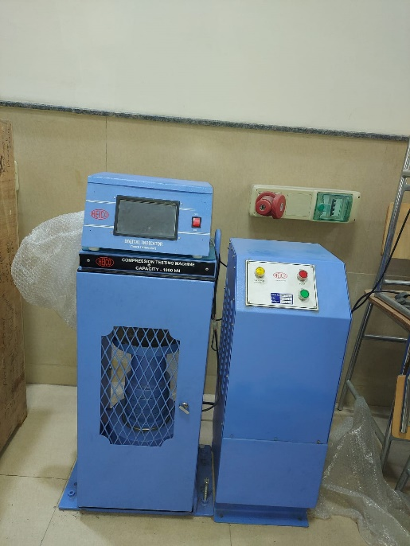

UCS

1. **UCA (Ultrasonic Cement Analyzer):**

Ultrasonic Cement Analyzers (UCAs) play a crucial role in the oil and gas industry's cementing operations. They provide non-destructive, real-time data on cement bond quality, enabling operators and engineers to optimize cementing processes, ensure wellbore integrity, and make informed decisions that contribute to the safety, efficiency, and environmental responsibility of well construction and maintenance.

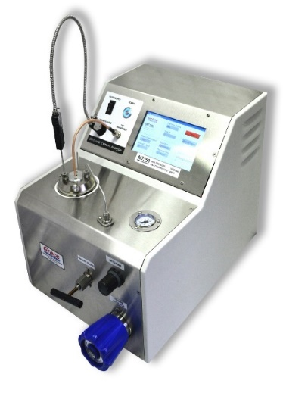

UCA

**Principle:**

The Ultrasonic Cement Analyzer (UCA) operates on the principle of ultrasonic pulse-echo technology. It uses high-frequency sound waves to evaluate the integrity and quality of cement bonds in wellbore construction. Here's a basic explanation of the principle of operation:

1. **Generation of Ultrasonic Waves**: The UCA generates high-frequency ultrasonic waves, typically in the ultrasonic range of 20 kHz to several megahertz. These waves are produced by a transducer or ultrasonic probe.
2. **Transmitting the Ultrasonic Waves**: The generated ultrasonic waves are transmitted into the cement sheath or the material being tested. In wellbore cementing, this is typically the cement sheath surrounding the casing or borehole.
3. **Propagation of Ultrasonic Waves**: The ultrasonic waves propagate through the cement and travel in the form of acoustic waves. The speed of sound through the material is determined by its physical properties, including density and elasticity.
4. **Interaction with Cement**: As the ultrasonic waves travel through the cement, they interact with the material. The waves can be reflected, refracted, or attenuated based on the properties and condition of the cement.
5. **Receiving Echoes**: The UCA's transducer also functions as a receiver, capturing the echoes or reflected waves that return after interacting with the cement. The time it takes for these echoes to return to the transducer is measured precisely.
6. **Analysis of Time-of-Flight**: By analyzing the time it takes for the ultrasonic waves to travel through the cement and return as echoes (time-of-flight), the UCA calculates the speed of sound in the material.
7. **Assessment of Cement Quality**: The speed of sound is directly related to the integrity and quality of the cement bond. Variations in the speed of sound can indicate the presence of voids, cracks, incomplete bonding, or other anomalies in the cement sheath.
8. **Data Interpretation**: The UCA provides data and measurements that engineers can interpret. Variations in the speed of sound are quantified, allowing for an assessment of the cement bond's effectiveness and potential issues that may need remediation.

**Working:**

The Ultrasonic Cement Analyzer (UCA) is a specialized device used in the oil and gas industry to evaluate the quality and integrity of cement bonds in wellbore construction. Here's how a UCA typically works:

1. **Sample Preparation:** The process begins with the preparation of cement samples. These samples are typically cylindrical or rectangular in shape, similar to the shape of cement sheaths used in oil well casing. The samples are carefully cast and allowed to set under controlled conditions to simulate downhole cementing conditions.
2. **Ultrasonic Transducers:** The UCA is equipped with ultrasonic transducers, which are sensors that emit and receive ultrasonic waves. These transducers are typically placed on opposite sides of the cement sample.
3. **Wave Propagation:** The UCA emits high-frequency ultrasonic waves (typically in the range of 20-40 kHz) into one side of the cement sample. These waves travel through the cement and interact with the material.
4. **Speed of Sound Measurement:** The UCA precisely measures the time it takes for the ultrasonic waves to travel through the cement sample from the emitting transducer to the receiving transducer. This measurement is based on the principle that the speed of sound in a material is related to its density and stiffness. In cement, changes in bond quality and integrity alter the speed of sound.
5. **Data Analysis:** The UCA records the time-of-flight of the ultrasonic waves and uses this data to calculate the speed of sound through the cement sample. This speed is then compared to a reference value, often the speed of sound in water or deionized water (DI water). Deviations from the reference value indicate variations in cement properties.
6. **Interpreting Results**: By analyzing the data collected, engineers can assess the quality of the cement bond. Changes in the speed of sound may indicate issues such as poor bonding, voids, channels, or cracks within the cement sheath. These issues can affect zonal isolation and wellbore integrity.
7. **Reporting:** The results obtained from UCA testing are typically reported in terms of cement bond quality and integrity. Engineers can use this data to make informed decisions about well construction and remedial actions if necessary.
8. **Chemical & Additives:**

* **Anhy. CaCl2:**

Calcium Chloride is undoubtedly the most efficient and economical accelerator. It is available in regular grade (77% calcium chloride) and anhydrous grade (96% Calcium Chloride).

* **PAC-R: (Polyanionic Cellulose)**

It is a water-based filtration control agent which also provides viscosity and controls fluid loss. PAC-R is a cost-effective means of controlling fluid loss and increasing viscosity and it improves the quality of the filter cake in water-based drilling systems

* **Zinc Oxide:**

ZnO nanoparticles can improve the compressive strength of wellbore cement. When added in small quantities, they help in creating a denser and more compact cement matrix, resulting in increased mechanical strength. This is particularly important for maintaining wellbore integrity and ensuring zonal isolation.

* **Silicon Di-Oxide:**

Nano-silica particles have a high surface area, which helps in reducing fluid loss during the cementing process. They can block and seal pore spaces within the cement, preventing the loss of drilling fluids into the formation.

* **DI-Water:**

DI water is often used as a reference fluid in UCA testing. It provides a consistent and well-defined medium against which to measure the properties of cement samples. Using DI water as a reference allows for the standardization of testing conditions, ensuring that results are reliable and comparable.

* **N2 Gas:**

Nitrogen gas is employed to pressurize the UCA & HPHT filter press. This pressure control is crucial for ensuring that the cement samples are tested under the desired downhole pressure conditions. By varying the nitrogen pressure, engineers can simulate different wellbore pressures to assess cement bond quality under various scenarios.

# About The Results

**ZnO vs SiO2:**

**Compressive Strength Test Analysis:**

**HPHT Test Analysis:**

# What We Learn

We have gained a comprehensive understanding of the operations and functionalities of various equipment and tools, including the Waring Blender, Hamilton Beach mixer, autoclave, HPHT Filter Press, and UCA. Additionally, we have acquired knowledge of the fundamental concepts related to cementing operations in the oil and gas industry. Furthermore, we recognize the significance of different cement additives and their roles in enhancing cement properties and performance.

**Slurry Preparation:**

Cement slurry was made in the laboratory according to the API recommended practice for testing well cement API RP 10 B [27]. Firstly, the base cement slurry was prepared using class G cement. The required amount of cement was weighed using a weighing machine (Mettler Toledo, model ME204).

For Base Slurry:

|  |  |  |
| --- | --- | --- |
| S. No. | Component | Amount |
| 1 | CLASS G Cement | 300 gm |
| 2 | Anhy. CaCl2 | 0.2% (0.6 gm BWOC) |
| 3 | PAC-R | 0.5% (1.5 gm BWOC) |
| 4 | Water | 44% (132 gm BWOC) |

# Future Scope

We made diligent efforts to operate the UCA system, but unfortunately, we encountered technical challenges that have thus far prevented us from obtaining the desired results. While we have studied its working principles, we have yet to achieve successful outcomes in our testing.

UCA can be utilized to assess the consistency of cement slurry, and it provides a means to validate the compressive strength of the cement.

# Conclusion

* ZnO and SiO2 have shown promising results.
* PAC-R effectively reduces spurt loss.
* SiO2 demonstrates superior performance in HPHT tests compared to ZnO.
* SiO2 can be used at higher concentrations due to its cost-effectiveness and availability.
* Incorporating nano-silica particles into the cement suspension increases the water content in the cement, mitigating settling and enhancing cement tolerance during the early stages of cementation.
* ZnO provides higher compressive strength than SiO2. The choice of nanoparticle now depends on the specific objective of the operation.
* To enhance compressive strength, ZnO is preferred, while for reducing spurt loss, SiO2 is the preferred choice.
* Top of Form
* We understand the working of UCA (Ultrasonic Cement Analyzer).
* We are able to prepare cement slurry with Hamilton Beach Mixer also.

# References

[1] Sanaa Goyal, Pradeep Joshi, Rakesh Singh, Rohan, Applications and role of Nano-Silica particles on altering the properties and their usage for oil well cementing,

DOI: [10.1016/j.matpr.2021.01.435](https://dx.doi.org/10.1016/j.matpr.2021.01.435)

[2] Fahad Khan, Himanshu Kesarwani, Gaurav Kataria, Govind Mittal & Shivanjali Sharma (2022): Application of titanium dioxide nanoparticles for the design of oil well cement slurry – a study based on compressive strength, setting time and rheology, Journal of Adhesion Science and Technology,

DOI: 10.1080/01694243.2022.2087963

[3] Alexander Anya, Hossein Emadi, Marshall Watson, Effect of size and shape of oil well cement test specimen on uniaxial compressive strength measurements

DOI: [10.1016/j.petrol.2020.107538](https://dx.doi.org/10.1016/j.petrol.2020.107538)

[4] Robert F. Mitchell Stefan Z. Miska, Fundamental of Drilling Engineering, SOCIETY OF PETROLEUM ENGINEERS, Chapter 4: Cementing (Page No. 139-178)

[5] Salaheldin Elkatatny, Mohamed Mahmoud, Hisham A. Nasr-EI-Din,Filter Cake Properties of Water-Based Driiiing Fiuids Under Static and Dynamic Conditions Using Computed Tomography Scan

DOI: [10.1115/1.4023483](https://dx.doi.org/10.1115/1.4023483)

[6] Shivshambhu Kumar, Achinta Bera, Subhash N. Shah, Potential applications of nanomaterials in oil and gas well cementing: Current status, challenges and prospects,

DOI: [10.1016/j.petrol.2022.110395](https://dx.doi.org/10.1016/j.petrol.2022.110395)

[7] Petro Ezekiel Mabeyo a,b , Yusra Salmin Ibrahim a , Jun Gu, Effect of high metakaolin content on compressive and shear-bond strengths of oil well cement at 80°C,

DOI: [10.1016/j.conbuildmat.2019.117962](https://dx.doi.org/10.1016/j.conbuildmat.2019.117962)

[8] Hussian Rabia, Well Engineering and Construction, Chapter 6 Cementing (Page No 201-264)

[9] American Petroleum Institute, Recommended Practice for Testing Well Cements, API Recommended Practice 10B-2 Second Edition, APRIL 2013 (R2019), 2013.

[10] P. Souza, R. Soares, M. Anjos, J. Freitas, A. Martinelli, D. Melo, Cement slurries of oil wells under high temperature and pressure: the effects of the use of ceramic waste and silica flour, Brazilian J. Pet. Gas. 6 (2012) 105–113.

DOI: [10.5419/bjpg2012-0009](https://dx.doi.org/10.5419/bjpg2012-0009)